Develop a VB Project for chart values are stored in the database using DAO connectivity.

Form design:

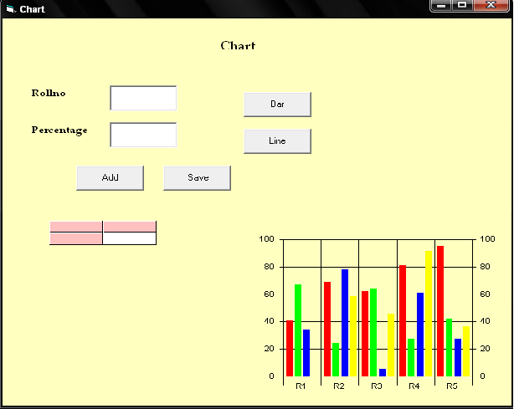

Properties:

Controls | Name | Caption
Text1 | Trno
Text2 | Tper
Command1 | Cmdadd | Add
Command2 | Cmdsave | Save
Command3 | Cmdbar | Bar
Command4 | Cmdline | Line
Msflexgrid | G
Mschart | c

13.Chart
Aim:
To develop a VB Project for chart values are stored in the database using DAO connectivity.

Coding:
Dim db As Database
Dim rs As Recordset
Private Sub cdadd_Click()
trno = " "
tper = " "
rs.AddNew
cdadd.Enabled = False
cdsave.Enabled = True
End Sub

Private Sub cdbar_Click()
c.chartType = 1
displayinfo
displaychart
End Sub

Private Sub cdline_Click()
c.chartType = 3
displayinfo
displaychart
End Sub

Private Sub cdsave_Click()
rs!rno = trno
rs!per = Val(tper)
rs.Update
cdadd.Enabled = True
cdsave.Enabled = False
displayinfo
End Sub

Private Sub Form_Load()
Call align
Set db = OpenDatabase("F:\Lab Programs\VB Record\13.Chart\ct.mdb")
Set rs = db.OpenRecordset("select * from tt", dbOpenDynaset)
If rs.RecordCount > 0 Then
displayinfo
End If
cdsave.Enabled = False
c.Visible = True
c.ColumnCount = 1
c.RowCount = 5
displaychart
End Sub

Private Sub align()
g.TextMatrix(0, 0) = "Rollno"
g.TextMatrix(0, 1) = "Percentage"
g.ColWidth(0) = 1500
g.ColWidth(1) = 1500
End Sub

Private Sub displayinfo()
rs.MoveFirst
i = 1
g.Rows = 1
Do While Not rs.EOF
g.Rows = g.Rows + 1
g.TextMatrix(i, 0) = rs!rno
g.TextMatrix(i, 1) = rs!per
rs.MoveNext
i = i + 1
Loop
End Sub

Private Sub displaychart()
Dim r1, r2, r3, r4, r5 As Integer
If rs.RecordCount > 0 Then
rs.MoveFirst
Do While Not rs.EOF
If rs!per > 40 And rs!per <= 50 Then
r1 = r1 + 1
End If
If rs!per > 50 And rs!per <= 60 Then
r2 = r2 + 1
End If
If rs!per > 60 And rs!per <= 70 Then
r3 = r3 + 1
End If
If rs!per > 70 And rs!per <= 80 Then
r4 = r4 + 1
End If
If rs!per > 80 And rs!per <= 100 Then
r5 = r5 + 1
End If
rs.MoveNext
Loop
End If
c.Row = 1
c.RowLabel = "41-50"
c.Data = r1
c.Row = 2
c.RowLabel = "51-60"
c.Data = r2
c.Row = 3
c.RowLabel = "61-70"
c.Data = r3
c.Row = 4
c.RowLabel = "71-80"
c.Data = r4
c.Row = 5
c.RowLabel = "81-100"
c.Data = r5
End Sub

Output:
